AS 1692—2006

(Incorporating Amendment No. 1)

Australian Standard®

Steel tanks for flammable and combustible liquids

This Australian Standard® was prepared by Committee ME-017, Flammable and Combustible Liquids. It was approved on behalf of the Council of Standards Australia on 20 January 2006.
This Standard was published on 22 February 2006.

The following are represented on Committee ME-017:

- A.C.T. WorkCover
- Australasian Fire Authorities Council
- Australian Chamber of Commerce and Industry
- Australian Industry Group
- Australian Institute of Petroleum
- Australian Paint Manufacturers Federation
- Department for Administrative and Information Services, S.A.
- Department of Consumer and Employment Protection, W.A.
- Department of Defence
- Department of Emergency Services, Queensland
- Department of Infrastructure, Energy and Resources, Tas.
- Plastics and Chemicals Industry Association
- Victorian WorkCover Authority

This Standard was issued in draft form for comment as DR 05392.

Standards Australia wishes to acknowledge the participation of the expert individuals that contributed to the development of this Standard through their representation on the Committee and through public comment period.
Keeping Standards up-to-date
Australian Standards® are living documents that reflect progress in science, technology and systems. To maintain their currency, all Standards are periodically reviewed, and new editions are published. Between editions, amendments may be issued.

Standards may also be withdrawn. It is important that readers assure themselves they are using a current Standard, which should include any amendments that may have been published since the Standard was published.

Detailed information about Australian Standards, drafts, amendments and new projects can be found by visiting www.standards.org.au

Standards Australia welcomes suggestions for improvements, and encourages readers to notify us immediately of any apparent inaccuracies or ambiguities. Contact us via email at mail@standards.org.au, or write to Standards Australia, GPO Box 476, Sydney, NSW 2001.

AS 1692—2006

(Incorporating Amendment No. 1)

Australian Standard®

Steel tanks for flammable and combustible liquids

COPYRIGHT
© Standards Australia
All rights are reserved. No part of this work may be reproduced or copied in any form or by any means, electronic or mechanical, including photocopying, without the written permission of the publisher.
Published by Standards Australia, GPO Box 476, Sydney, NSW 2001, Australia

1. PREFACE
(1) This Standard was prepared by Standards Australia Committee ME-017, Flammable and Combustible Liquids to supersede AS 1692—1989.
(2) This new edition has been revised to include new standards and designs to which tanks may be constructed and tested. References to ‘approvals’ by authorities have been removed, in line with current regulatory practices.
(3) This Standard incorporates Amendment No. 1 (August 2006). The changes required by the Amendment are indicated in the text by a marginal bar and amendment number against the clause, note, table, figure or part thereof affected.
(4) The objective of this Standard is to provide requirements and recommendations for the design and construction of a range of types of steel tanks suitable for the storage of flammable and combustible liquids.
(5) This Standard is limited to tanks made of steel and stainless steel, and includes tanks with integral secondary containment.
(6) Thicknesses of materials are based on empirical data, being the result of experience rather than stress calculations, the exception being tanks of Category 6 (e.g. those built to API 650).
(7) The term ‘normative’ has been used in this Standard to define the application of the appendix to which it applies.
(8) A ‘normative’ appendix is an integral part of the Standard.

STANDARDS AUSTRALIA

Australian Standard
Steel tanks for flammable and combustible liquids

- SCOPE AND GENERAL

1.1. SCOPE
(1) This Standard is within scope if-
(a) there is an issue in relation to the design or construction of a steel tank;
(b) the tank is used to store substances that are liquid at normal temperatures and pressure; and
(c) the shell thicknesses of the tank specified in this Standard are within assumptions
(2) The shell thicknesses of the tank specified in this Standard are within assumptions if-
          - stresses on the tank will be comparatively low;
          - the liquid being stored is no more corrosive than normal petroleum products;
          - the density of the liquid being stored is not greater than 1000 kg/m3;
          - the tank needs to be reasonably sturdy for handling and any transport;
          - an allowance for corrosion has been made;
          - liquid levels after normal filling will not be substantially above the ‘tank full’ level;
          - allowance is not made for the effect of filling an extended pipe to a level that is substantially above that of the tank;
          - the pressure in the vapour space will not exceed 35 kPa;
          - the length-to-diameter ratio of an above-ground tank on two supports does not exceed 5;
          - the tank shell is not stiffened; and
          - the material of construction is commercial-grade, low-carbon steel.
(3) This Standard sets out requirements for tank joints and accessories (e.g. vents, manholes, fill level indicators) and specifies tank testing requirements.
(4) The possibility of using thinner materials, compensating by shaping, corrugating, bracing or stiffening, is recognized, especially for stainless steel.
(5) In such cases the design will need to demonstrate mechanical properties that are at least equivalent to a similar size of tank built to this Standard if such a tank is to be used for flammable or combustible liquids.
(6) This Standard does not insist on compliance with any particular material Standards, or the use of specific grades of materials.
  - APPLICATION
          - This Standard applies if-
            - this Standard is within scope;
            - the tank is constructed of commercial grade low carbon steel or stainless steel;
            - the tank is for the storage of flammable or combustible liquids;
            - the issue does not relate solely to the installation of the tank;
            - the tank is not part of a road, rail or marine tanker; and
            - the tank is not a fuel tank for a vehicle or marine craft
          - It also applies to tanks with integral secondary containment such as those approved by Underwriters Laboratories (UL) and having a fire-rated secondary containment.
          - Alternative materials of construction (e.g. glass-fibre reinforced plastics (GRP), other plastics and aluminium and its alloys) are not covered by this Standard, although GRP is recognized as an alternative material for underground storage tanks.
  - CATEGORIES OF TANKS
          - A tank is a Category 1 tank if-
            - the capacity of the tank is less than 1200 L;
            - the tank is for above-ground use; and
            - the tank is intended principally for the storage of fuel oil in domestic situations.
          - A tank is a Category 2 tank if-
            - the tank is vertical or horizontal tank;
            - the capacity of the tank is less than 2500 L;
            - the tank is for above-ground use; and
            - the tank is intended principally for use on farms or other open space locations.
          - A tank is a Category 3 tank if-
            - the tank is rectangular or has an unconventional shape;
            - the tank is for above-ground use; and
            - the tank is intended principally for industrial use as either a head tank or storage tank.
          - A tank is a Category 4 tank if-
            - the tank is a horizontal tank;
            - the tank is a cylindrical tank;
            - the capacity of the tank is less than 150000 L;
            - the tank is intended principally for industrial or service station use.
          - A tank is a Category 5 tank if-
            - the tank is a horizontal tank;
            - the tank is a cylindrical tank;
            - the capacity of the tank is less than 150000 L;
            - the tank is for above-ground use; and
            - the tank is intended principally for industrial use.
          - A tank is a Category 6 tank if-
            - the tank is a vertical tank; and
            - the tank is of a type that is usually erected on site.
          - Appendix A provides further information that needs to be provided by the purchaser to the manufacturer of the tank.
          - Category 1 tanks cannot be used for the storage of flammable liquids, as they do not incorporate a liquid seal.
  - REFERENCED DOCUMENTS
A list of the documents referred to in this Standard is given in Appendix B.
  - DEFINITIONS
For the purposes of this Standard, the following definitions apply:
    - Capacity
The maximum volume or space within a container, i.e. the volume it can hold without overflow or leakage.
- The available capacity of a container is normally less than its full capacity, because of the need to provide an ullage space to allow for thermal expansion. A common practice is to allow 3% for ullage, but local regulations or factors such as tank size, sheltered locations or underground installation may all have a bearing on the ultimate figure used.
    - Combustible liquid
Any liquid, other than a flammable liquid, that has a flash point, and has a fire point that is less than its boiling point.
- The boiling point is that point at which it is no longer possible to achieve the rate of temperature rise required by ISO 2592 for the determination of fire point.
    - Flammable liquids
Liquids, or mixtures of liquids, or liquids containing solids in solution or suspension (e.g. paints, varnishes, lacquers, etc., but not including substances otherwise classified on account of their dangerous characteristics) which give off a flammable vapour at temperatures of not more than 60.5°C, closed cup test, or not more than 65.6°C, open cup test, normally referred to as the flash point.
- Reference should be made to the ADG Code.
    - Liquid
A flammable or combustible liquid as defined above and in AS 1940.
    - Nominal thickness
The nominal thickness of a material that is commercially available and to which specified manufacturing tolerances apply.
- GENERAL DESIGN AND CONSTRUCTION REQUIREMENTS FOR TANKS OF CATEGORIES 1 TO 5
  - SCOPE OF SECTION
This Section sets out general requirements for the design and construction of tanks of Categories 1 to 5.
  - GENERAL REQUIREMENTS
    - Design suitability
Any storage tank shall be designed so that it is adequate for any load and pressure to which it might be subjected, and shall take into account any corrosive or abnormal conditions.
Welded-on fittings, flanges, nozzles and the like, shall be compatible with the material of construction of the tank and the welding process.
Where the density of the liquid to be stored is greater than 1000 kg/m3, the tank shall be designed to accommodate this density when selecting and calculating its materials of construction and their dimensions, e.g. wall thicknesses, joints. Similar calculations shall be carried out if a greater corrosion rate than that for petroleum fuel-type products is expected, and materials shall be selected accordingly.
    - Materials of construction
Any material used in the construction of the tank shall be of a type and quality suitable for the conditions for use and compatible with the liquid to be stored. Material should comply with the relevant Australian or other appropriate Standard.
    - Welded joints
Any welded joint shall comply with the relevant requirements of AS/NZS 1554 series.
A1
    - Finishes and protective coatings
Any internal or external protective coatings shall be sufficient to ensure the satisfactory life of the tank and its supports.
A1
Particular attention should be paid to the following:
          - The soil or atmospheric conditions surrounding the tank.
          - Compatibility of internal coatings with the contents of the tank.
          - Protection of areas particularly vulnerable to corrosion, e.g. points of contact with the supports, rainwater traps.
          - Any specific requirements for surface preparation and coatings where cathodic protection is used.
    - Tank supports
Any supporting structure that is supplied with the tanks shall comply with the structural code applicable for the particular materials, e.g. AS 4100 for steel supports. Any welded-on supports, brackets or other fittings shall be welded so that moisture cannot penetrate in a manner that could lead to corrosion of the tank shell.
Particular attention should be paid to the method of transmitting loads between the tank shell and the supports so that local overstressing or distortion of the tank is avoided.
    - Connections to underground tanks
Where a tank is to be partly or wholly buried below ground level, all pipe entries shall be through the top of the tank.
    - Liquid seal
Every fill pipe, suction pipe or dip pipe that enters through the top of the tank and that is likely to be opened to atmosphere at some time during normal filling, shall be provided with a liquid seal sufficient to ensure that the lower end of the pipe is submerged in at least 25 mm of liquid at all times after the initial filling.
Category 1 tanks are exempt from this requirement.
- Figure 2.1 shows typical arrangements for liquid seals.
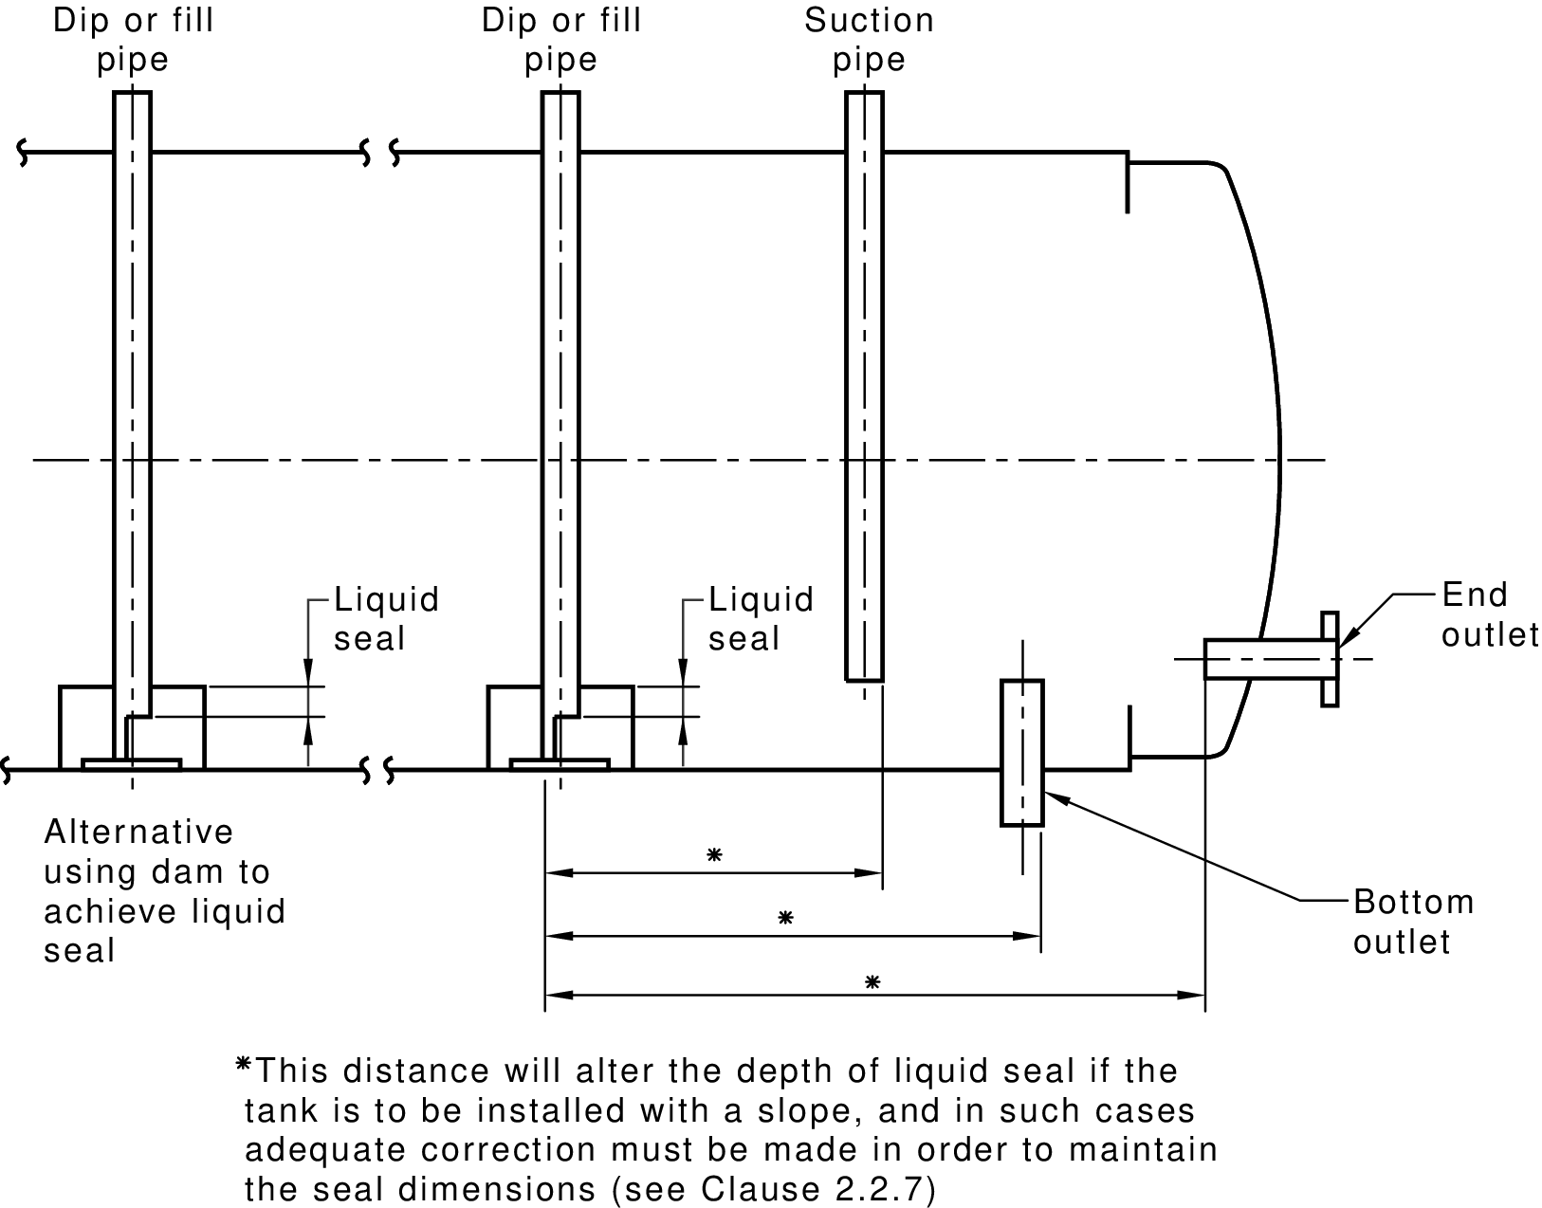
FIGURE 2.1 LIQUID SEAL PROVISIONS
    - Access ladders and structures
Any access structure shall comply with AS 1657. Where such a structure is attached to the tank, it’s design shall be such that there is no differential movement between the tank and the structure.
  - LIQUID LEVEL INDICATION
    - General
Each storage tank shall be provided with a means of ascertaining the level of liquid within it. If the indicator is of a type designed for reading at a remote location, additional facilities for checking its accuracy shall be provided.
The maximum permitted filling level shall be indicated on the gauge.

Any change to the contents of the tank may alter the maximum permitted filling level.
Acceptable types of indicator are float gauges, hydrostatic pressure gauges, dipsticks, dip tapes or sight tubes (gauge glasses).
    - Dipsticks
Where a dipstick system is used, it shall comply with the following requirements:
          - On an above-ground tank, the opening shall be provided with a cap that is liquid-tight and vapour-tight unless a common dip and vent is used.
          - Where measurement is made with the dipstick in contact with the bottom of the tank, a tubular dipstick guide shall be provided. The guide shall incorporate a pressure equalizer hole that connects the upper end of the dip pipe with the upper tank space. If the pressure equalizer hole is more than 1.5 mm diameter, it shall be covered with anti-flash gauze not coarser than 600 μm mesh. For tanks of categories other than 1 or 2, a durable striker pad shall be attached firmly to the tank bottom below the dip opening.
          - Any dipstick for a tank intended to contain flammable liquids shall be of non-ferrous metal.
    - Sight tubes
A sight tube (also known as a gauge glass) shall not be fitted to any tank for flammable liquids, and should not be used for any other liquid unless such use is unavoidable.
Where the use of a sight tube is unavoidable—
          - an adequate protective guard shall be provided for the tube;
          - the material of the sight tube shall be impervious to and compatible with the liquid being stored; and
          - a self-closing shut-off valve shall be provided on any connection leg that is below the liquid level.
  - FILLING PROVISIONS
    - General
Each tank shall be provided with a suitable means of filling, taking into account the intended filling method and the location of the fill point in relation to the tank.
- The means of filling should be agreed between the purchaser and supplier of the tank.
For a top-filled tank, a weatherproof cap, cover or plug should be provided with the tank.
    - Fill pipe
The fill provision for tanks of other than Category 1 shall be such that the liquid flows through a fully enclosed pipe to a discharge point that is not more than one pipe diameter above the bottom of the tank.
Where the tank is filled from the top, an extension pipe shall be used, in order to comply with this requirement.
Where the side entry into a vertical tank has to be reinforced, the discharge point may be located high enough to accommodate the reinforcing ring, but should not be more than 150 mm from the tank bottom.
- This requirement is intended to reduce splashing during filling, which could result in the generation of static electricity, is minimized. See AS/NZS 1020.
    - Pressure equalization
Any fill pipe that fills downwards into a tank shall incorporate a pressure equalizer hole that connects the upper end of the pipe with the upper tank space. If the pressure equalizer hole is more than 1.5 mm diameter, it shall be covered with anti-flash gauze not coarser than 600 μm mesh.
    - High-head filling
Where the height of the fill point is above the tank, such that the pressure on the tank will exceed the test pressures described in Clause 2.8, the tank shall either—
          - incorporate a provision to prevent the liquid level rising above the full level; or
          - be designed and tested to withstand the additional pressure of a liquid-full filling extension.
  - DRAINING AND NORMAL DRAW-OFF
It shall be possible to remove all of the tank’s liquid contents, without moving the tank from its installed position.
Any drain provision should draw from the lowest point of the tank and, if separate from the liquid draw-off pipe, should be located as far as possible from the draw-off pipe.
Where the conditions of installation are such that draining by gravity through a bottom outlet cannot be provided, e.g. an underground tank, facility for the insertion of a suction spear though a fill pipe or other opening are deemed to comply with the above requirement.
  - MANHOLES
    - General
A manhole shall be provided when specified by the tank purchaser.
- A manhole is not essential for tank safety, but may be convenient during construction, or for the maintenance, cleaning or inspection of the tank and any equipment inside it.
    - Size of manholes
Any manhole shall be at least the following minimum sizes:
          - If elliptical, 450 mm × 400 mm.
          - If circular, 450 mm diameter.
          - If the manhole neck is more than 200 mm high, 600 mm diameter.
These sizes should be exceeded wherever possible. Where breathing apparatus may be required for personnel entering the tank, the manhole should be at least 600 mm in diameter.
    - Multiple manholes
Where a vertical tank is greater than 3 m high and is required to have a manhole near its top, a second manhole shall be provided near the bottom of the tank. If a single manhole is located near the bottom of the tank, no other manhole is required unless specified by the purchaser.
    - Manhole covers
Each manhole shall be provided with a cover that is vapour-tight and liquid-tight at the test pressure.
  - TANK VENTS
    - General
Each tank shall incorporate a provision for the vapour space above the liquid to vent to atmosphere. The vent may be combined with the filling provision for a Category 1 tank. For all other categories of tank, the vent shall be separate from the fill orifice.
The venting provision shall be one of the following:
          - Free venting, where the vapour space is in contact with the atmosphere without any intervening valves or other devices, so that the pressure above the liquid is substantially that of the surrounding atmosphere.
          - Pressure-vacuum venting (PV vents), where a control device permits a positive or negative pressure within the tank to reach a predetermined level before the pressure or vacuum is relieved.
          - Emergency venting, used to supplement Items (a) and (b) above, where excessive pressure build up in emergency conditions such as fire is relieved by means of a pressure-relief device.
    - Size of vent
The size of any free vent or pressure-vacuum vent shall be such that pressure or vacuum resulting from filling or emptying or atmospheric temperature change will not cause stresses greater than the normal maximum design stress.
The design of the vent, and particularly its size, are dependent on factors that relate to the specific installation; therefore a tank manufacturer would not normally undertake to design and size the vent without instructions from the purchaser.
In determining the size of the vent connection, the following requirements shall apply:
          - Where a free vent in a Category 1 tank is combined with the filler, the opening shall provide at least 600 mm2 of free vent area with the nozzle inserted and 10 mm2 with the cap in place.
          - For a separate free vent in a tank of Category 1 or Category 2, the vent area shall be the equivalent of a 25 mm nominal internal diameter pipe.
          - For any other category of tank, the vent provision or the vent connection facilities shall be those specified by the purchaser of the tank.
    - Vent terminal
The discharge end of any free vent supplied as part of a tank shall be protected from the ingress of foreign material, e.g. by a return bend or a protective cap, cage, or fitting. Any such fitting shall not reduce the required vent area.
The discharge point of the free vent shall be higher than the filling point of the tank and at least 150 mm above the tank top.
  - TESTING
    - Leakage test
Each tank shall be subjected to a leakage test before any painting, coating, or similar treatment is applied, and shall be found to be sound and liquid-tight before being put into service. A hydrostatic test method should be used, but air testing may be applied in the conditions specified in Clause 2.8.3 to any tank except those of Categories 3 or 6.
    - Hydrostatic testing
Hydrostatic testing shall be carried out with the tank in the orientation of its operation, i.e. vertical tanks shall be tested when vertical, horizontal tanks tested when horizontal.
- Any flat side or end may be supported during testing, provided that the method of support does not inhibit the observation of any leak.
Any hydrostatic test shall be carried out in accordance with the following requirements, as applicable:
          - For any free-vented tank in Categories 1, 2, or 5, the test pressure shall be that caused when the tank is filled with water and 1 m additional water head is applied. Where the tank filling or operating pressure will exceed the equivalent of 1 m head above the top of the tank, the test pressure shall be that maximum pressure plus 1 m head of water.
          - For any free-vented Category 3 tank, the test pressure shall be as in (a) above, except that the additional head shall be reduced to 150 mm.
          - For any Category 6 tank, the test pressure and procedure shall be that given in the Standard to which the tank was built.
          - Where a pressure-vacuum or emergency vent is to be used with the tank, the test pressure shall be as in (a) above, plus 35 kPa.
          - The test pressure shall be applied for sufficient time to allow any leaks to develop and to be observed.
- The purchaser is free to specify higher test pressures, but the design of the tank should be checked for its ability to withstand any such pressures.
    - Air testing
Any air test shall be conducted in accordance with the following requirements:
          - Air testing shall be applied only to new tanks and at the manufacturer’s premises.
          - The test pressure shall be such as to provide stress to a level equivalent to that which would be caused by the appropriate hydrostatic test pressure, but shall not exceed 35 kPa.
          - When air for testing is taken from a source of supply having a pressure greater than 35 kPa, pressure shall be reduced by means of a pressure-reducing device. A pressure gauge, safety valve, or hydrostatic pressure-relieving device, and a pressure release cock shall be fitted on the low pressure side.
          - A tank that is to be filled from a filling point more than 1 m above the tank shell shall be tested at the head resulting from the filling location, plus an additional 1 m head of water.
          - The pressure-relieving device shall be capable of discharging the maximum delivery of the pressure-reducing device without rise in pressure beyond 110% of the test pressure.
          - The tank shall not be subjected to blows while under air pressure.
          - Air for testing shall be introduced gradually and evenly until the test pressure has been reached.
          - The test pressure shall be applied for sufficient time to allow any leaks to develop and to be observed.
  - HANDLING AND TRANSPORT
Any tank that could suffer damage because of stresses caused by handling and transportation shall be provided with adequate supports and stays to protect it until it has been installed.
- Lifting lugs may be provided.
  - TANKS WITH FIRE-RATED COVERINGS
Tanks having fire-rated coverings, including ‘vaulted’ tanks that comply with UL 2085 and those approved by Underwriters Laboratories (UL) or Factory Mutual (FM) to the equivalent of US fire rating, that meet such criteria, are deemed to comply with this Standard (see also AS 1940).
- REQUIREMENTS FOR SPECIFIC CATEGORIES OF TANKS
  - SCOPE OF SECTION
This Section sets out requirements for tanks, specific to their category as given in Clause 1.3.
  - CATEGORY 1 TANKS
    - Size limitation
A Category 1 tank shall not exceed 1200 L capacity.
    - Material
The material of construction of any Category 1 tank shall be not less than 1.6 mm nominal thickness low carbon steel or 1.2 mm stainless steel. The tank shall be made so that when completely filled in service no flat side shall bulge by an amount greater than 2% of the lesser dimension of that side.
  - CATEGORY 2 TANKS
    - Size limitation
A Category 2 tank shall not exceed 2500 L capacity.
    - Material
The material of construction of any Category 2 tank shall be not less than 2 mm nominal thickness low carbon steel, or 1.6 mm stainless steel. For a vertical tank, the bottom shall be not less than 3 mm nominal thickness low carbon steel or 2.5 mm stainless steel.
  - CATEGORY 3 TANKS
    - Material
The material of construction of any Category 3 tank shall be not less than the relevant nominal thickness given in Table 3.1.

Thicknesses are empirical, based on the assumptions given in Clause 1.1.
Tanks that are rectangular or of other unconventional shape should be treated with caution because of the design problems involved.
    - Plate stiffness
Any rectangular tanks shall be made so that when completely filled in service, no side shall bulge by an amount greater than 2% of the lesser dimension of that side.
TABLE 3.1
THICKNESS OF MATERIAL FOR RECTANGULAR
TANKS OF CATEGORY 3
Capacity  L |  | Minimum nominal thickness  mm |  | Thickness valid up to tank height  m | Increase thickness for each 1 m extra height  mm
 |  | Low carbon steel | Stainless steel
 | ≤50 | 0.8 | 0.6 | 0.5 | 0.5
>50 | ≤250 | 1.0 | 0.8 | 1.0 | 0.5
>250 | ≤500 | 1.6 | 1.0 | 1.0 | 0.5
>500 | ≤1200 | 3.0 | 2.5 | 1.5 | 1.5
>1200 | ≤5000 | 5.0 | 4.0 | 1.5 | 1.5
>5000 |  | Each flat surface shall be individually designed for the pressure to be withstood.
  - CATEGORY 4 TANKS
    - Material
The material of construction of any Category 4 tank shall be not less than the nominal thickness given in Table 3.2. The thicknesses given in Table 3.2 are applicable to tanks whose length does not exceed 5 times their diameter.
- Thicknesses are empirical, based on certain assumptions that are outlined in Clause 1.1.
Category 4 includes underground tanks for service station use, which are constructed from glass-fibre-reinforced plastics. In such cases, tanks shall comply with UL 1316.
TABLE 3.2
THICKNESS, SHELLS AND ENDS FOR HORIZONTAL
CYLINDRICAL TANKS FOR CATEGORY 4
Tank diameter  m |  | Minimum nominal thickness  mm
 |  | Low carbon steel | Stainless steel
 | ≤1.53 | 3 | 2.5
>1.53 | ≤2.20 | 5 | 4
>2.20 | ≤2.75 | 6 | 5
>2.75 | ≤3.75 | 8 | 6
    - Tank ends
Any conical or dished end shall be formed to a height not less than that given in Table 3.3. Any flat end shall be stayed or stiffened in accordance with AS 1210.
TABLE 3.3
MINIMUM HEIGHT OF DISHED OR CONICAL ENDS
FOR TANKS FOR CATEGORY 4
Tank diameter  m |  | Dished height  mm
 | ≤1.53 | 40
>1.53 | ≤2.20 | 70
>2.20 | ≤2.75 | 110
>2.75 | ≤3.75 | 200
The dished height does not include the straight length of any flange, i.e. dimension F of Figure 3.1 is additional to the dished height.
    - Placing of supports
The location of a support in relation to the end of the tank shall be such that the shell will not fail due to loading in the vicinity of the support.
- AS 1210 provides methods for calculating stresses at supports.
    - Construction
The following requirements and recommendations apply to welded joints:
          - Any longitudinal welded joint shall be a butt joint (see Figure 3.1(a)).
          - Any circumferential welded joint in any tank which will incorporate pressure-vacuum venting, the pressure relief setting of which will exceed 14 kPa, shall be a butt joint or double-welded lap joint.
          - Any dished internal bulkhead within a tank shall be welded on at least one side.
          - Any circumferential welded joint in any tank other than as described in (b) above shall be of any of the forms shown in Figure 3.1, except where a purchaser specifically requires that a lap joint be seal-welded on the inside.
  - CATEGORY 5 TANKS
    - Material
The material of construction of any Category 5 tank shall be at least the nominal thickness given in Table 3.4.
- Thicknesses are empirical, based on the assumptions outlined in Clause 1.1.
    - Flat tank bottom
Where a tank is intended to be installed so that it rests on and is evenly and adequately supported over its entire bottom area, the bottom may be unstayed. If the tank is supported by means of a projecting rim, skirt, or legs without any other support for the bottom, then the bottom, if flat, shall be stayed and stiffened in accordance with AS 1210.
    - Bolting down
Any Category 5 tank shall incorporate provisions for bolting down, sufficient to withstand the forces involved, in the following circumstances:
          - Where wind loadings could dislodge or overturn the empty tank (see AS/NZS 1170.2).
          - Where an uplift force on a tank roof (due to the pressure setting of a vent) is greater than the mass of the roof and shell.

TABLE 3.4
THICKNESS, SHELLS AND ENDS FOR CYLINDRICAL VERTICAL
TANKS OF CATEGORY 5
Tank diameter  m |  | Shell  (See Notes 3 and 4)  mm |  | Bottom  mm |  |  |  | Top  mm
 |  |  |  | Flat  (See Notes 2 and 4) |  | Dished or coned  (See Notes 3 and 4) |  | Flat |  | Dished or coned
 |  | Low carbon steel | Stainless steel | Low carbon steel | Stainless steel | Low carbon steel | Stainless steel | Low carbon steel | Stainless steel | Low carbon steel | Stainless steel
 | ≤1.53 | 3 | 2.5 | 6 | 6 | 3 | 2.5 | 3 | 2.5 | 3 | 2.5
>1.53 | ≤2.20 | 5 | 4 | 6 | 6 | 5 | 4 | 5 | 4 | 3 | 2.5
>2.20 | ≤2.75 | 5 | 4 | 6 | 6 | 6 | 5 | 5 | 4 | 5 | 4
>2.75 | ≤3.75 | 6 | 5 | 6 | 6 | 8 | 6 | 6 | 5 | 5 | 4
>3.75 | ≤4.5 | 6 | 5 | 6 | 6 | 10 | 8 | 6 | 5 | 5 | 4
>4.5 |  | Design as a Category 6 tank
All thicknesses are nominal (see Clause 1.5.5).
Flat bottoms are assumed to be fully supported over at least 60 percent of their area (see Clause 3.6.2).
Dished or coned bottoms are assumed to be for tanks that rest on peripheral legs, so that the bottoms have no support. Tanks that are particularly tall, so that the liquid head is high, should be checked in accordance with AS 1210 to verify the adequacy of the shell and bottom thickness. The shell should also be checked for adequacy at the point of attachment of legs.
Consideration should be given to increasing thicknesses where damage due to transport, handling, and erection is likely.

    - Welded joints
Any welded joint shall comply with the following requirements and recommendations, as applicable:
          - Shell
Any longitudinal shell joint shall be a butt joint. Any circumferential shell joint should be a butt joint, but may be a lap joint (see Figure 3.1).
          - Bottom
If the tank rests on the tank bottom, the joint between the shell and the bottom may be a double-sided fillet joint. If the tank is on legs, such a joint shall be either a butt joint or a double-welded lap joint.
Any transverse seam across a tank bottom may be a single-welded lap joint (with the weld inside) if the tank rests on the tank bottom, or a butt joint or double-welded lap joint if the tank is on legs.
          - Tank top
Any of the joint types illustrated in Figure 3.1 and Figure 3.2 may be used. If the tank will incorporate pressure-vacuum venting and the pressure setting is more than 14 kPa, the joint between the shell and the top shall be reinforced as illustrated in Figure 3.2(c), and the design shall be in accordance with BS EN 14015. This requirement does not apply where a tank is less than 3 m in diameter, or where a tank incorporates a dished and flanged end.
  - CATEGORY 6 TANKS
A Category 6 tank shall comply fully with BS EN 14015, API 620, API 650, or other equivalent Standard.

Where the Standard chosen makes reference to another Standard of its country of origin, an Australian Standard may be substituted, provided that the substitution is appropriate and both parties to the purchase contract are agreeable.
A list of preferred sizes for Category 6 tank diameters, in metric dimensions, is given in BS EN 14015.

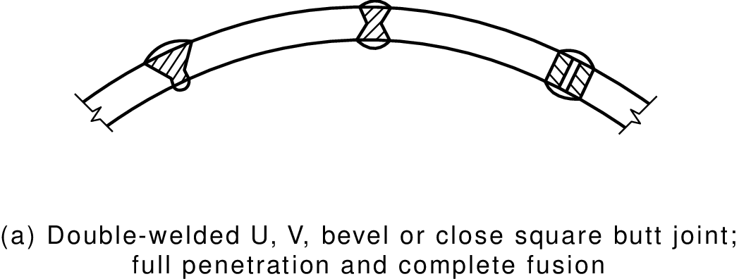
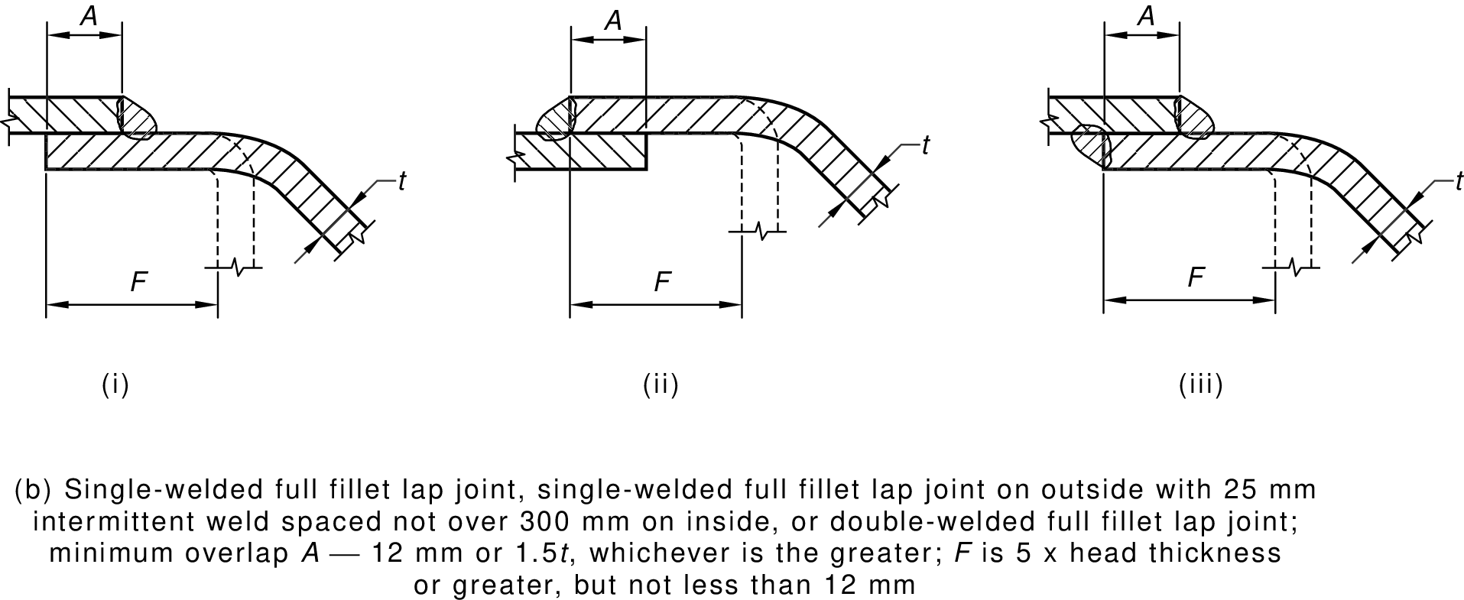

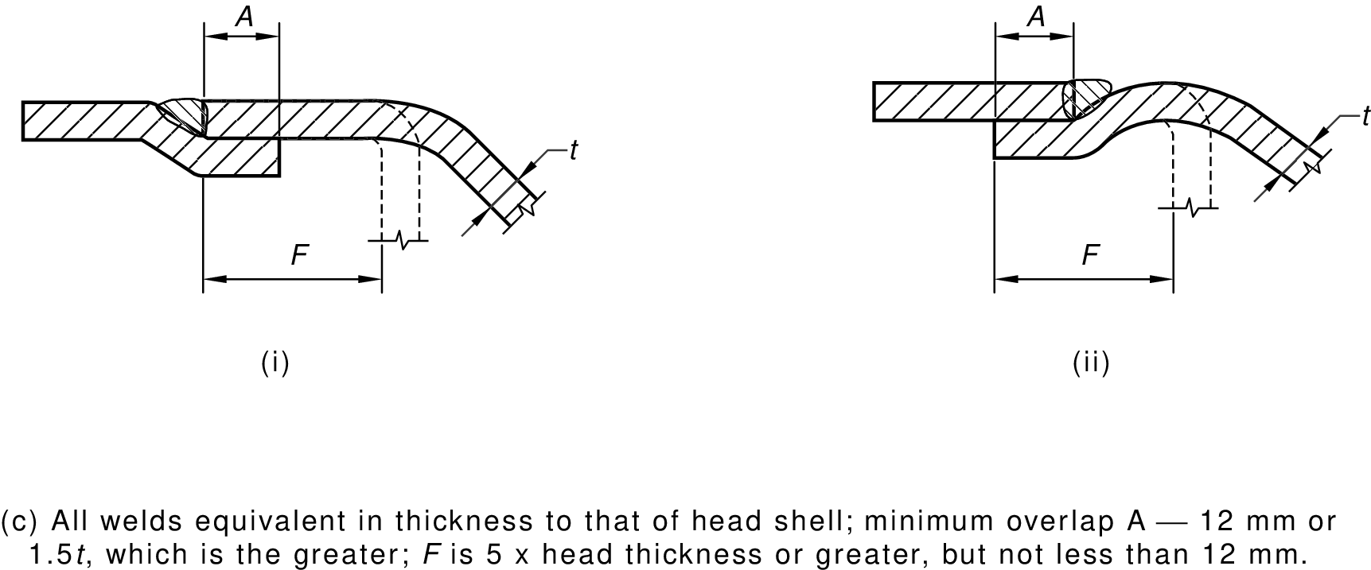
FIGURE 3.1 (in part) TYPICAL JOINTS FOR TANKS
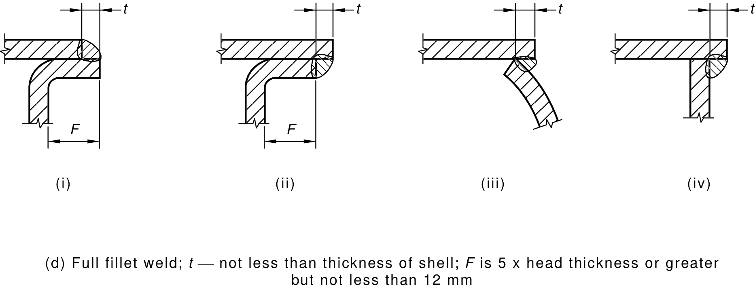
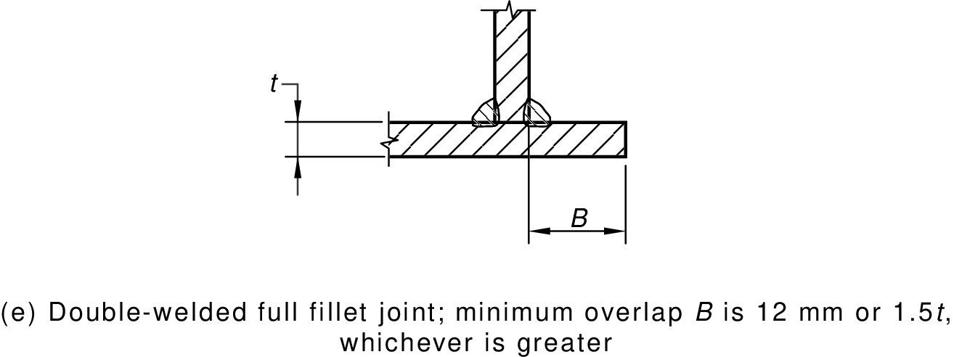
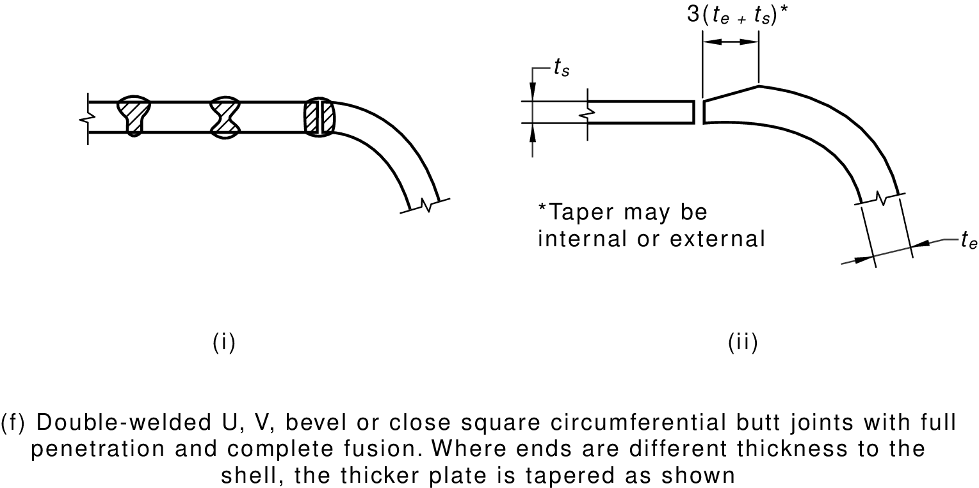

FIGURE 3.1 (in part) TYPICAL JOINTS FOR TANKS
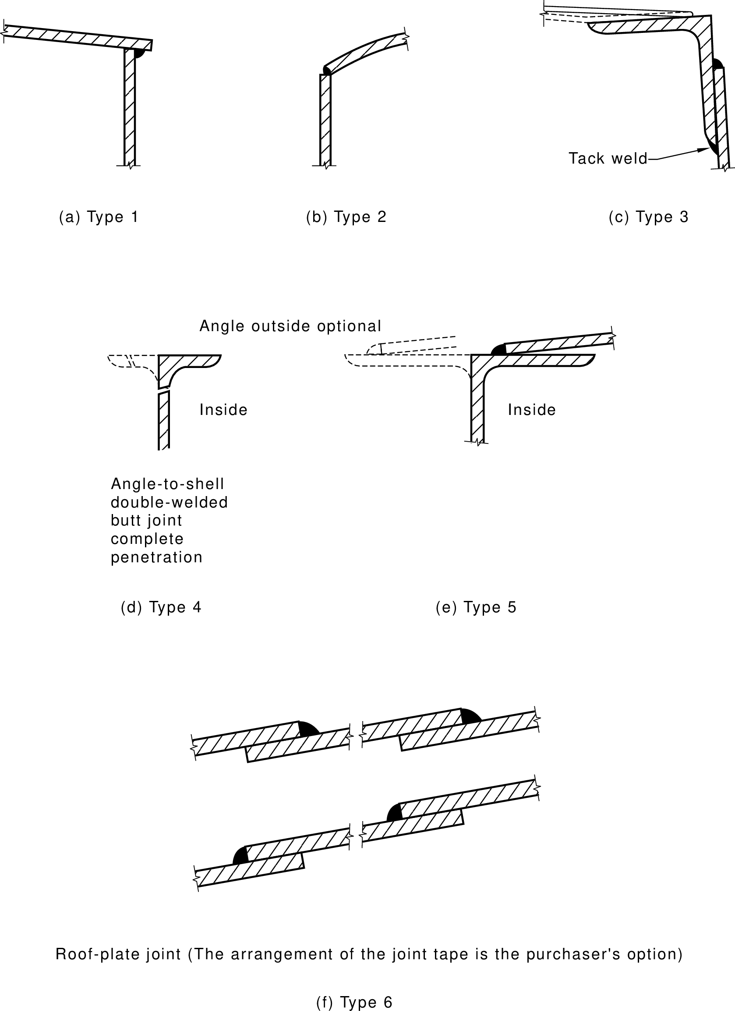
FIGURE 3.2 VERTICAL TANKS—ROOF JOINTS

INFORMATION TO BE PROVIDED BY THE PURCHASER

(Normative)
The purchaser shall provide the tank manufacturer with such information as is necessary to permit manufacture of the tank. In particular the following should be provided:
          - Whether the tank is to be above ground, or wholly or partly buried.
          - The type and nature of the filling provision required.
          - The test pressure, or the liquid head, or the pressure of operation.
          - The type and location of the draw-off connection.
          - Vent provision, i.e. the type, size, capacity, provision for any vent extension.
          - Whether a manhole or manholes are required and their location.
          - Whether a test certificate is required.
          - Whether calibration of tank or contents indicator is required.
          - Any finishing or protective coatings required.
          - The density of the liquid if it exceeds 1000 kg/m3.
          - Any special requirements regarding supports.
          - The product to be stored.

REFERENCED DOCUMENTS

(Normative)

AS
1210 | Pressure vessels
1657 | Fixed platforms, walkways, stairways and ladders—Design, construction and installation
1940 | The storage and handling of flammable and combustible liquids
4100 | Steel structures
AS/NZS
1020 | The control of undesirable static electricity
1170 | Structural design actions
1170.2 | Part 2: Wind actions
1554 | Structural steel welding (series)
ISO
2592 | Determination of flash and fire points—Cleveland open cup method
BS EN
14015 | Specification for the design and manufacture of site-built, vertical, cylindrical, flat-bottomed, above ground, welded steel tanks for the storage of liquids at ambient temperature and above
ADVISORY COMMITTEE ON THE TRANSPORT OF DANGEROUS GOODS
ADG Code | Australian Dangerous Goods Code
API | AMERICAN PETROLEUM INSTITUTE
620 | Design and Construction of Large, Welded, Low-pressure Storage Tanks
650 | Welded Steel Tanks for Oil Storage
UL | UNDERWRITERS LABORATORIES
1316 | Glass-Fibre-Reinforced Underground Storage Tanks for Petroleum Products, Alcohols, and Alcohol-Gasoline Mixtures
2085 | Protected Aboveground Tanks for Flammable and Combustible Liquids

